Optimizing EV Charging Station Routing: A Comparative Analysis of Bellman-Ford and Floyd-Warshall, Johnson's and Yen's K-Shortest Paths Algorithms
A PROJECT REPORT
Submitted by
BL.EN.U4CSE22160 U. Aditya
BL.EN.U4CSE22133 N.Shreyas
BL.EN.U4CSE22176 V.Sreevanth
in partial fulfillment for the award of the degree of

BACHELOR OF TECHNOLOGY
IN
COMPUTER SCIENCE AND ENGINEERING

AMRITA SCHOOL OF ENGINEERING, BENGALURU

AMRITA VISHWA VIDYAPEETHAM
BENGALURU 560 035
November-2024

ACKNOWLEDGEMENTS
The satisfaction that accompanies successful completion of any task would be incomplete without mention of people who made it possible, and whose constant encouragement and guidance have been source of inspiration throughout the course of this project work. We offer our sincere pranas at the lotus feet of “AMMA”, MATA AMRITANANDAMAYI DEVI who showered her blessing upon us throughout the course of this project work. We owe my gratitude to Prof. Manoj P., Director, Amrita School of Engineering, Bangalore.
We thank Dr. Sriram Devanathan, Principal, Amrita School of Engineering, Bangalore for his support and inspiration. We also thank Dr. Gopalakrishnan E. A., Chairperson and Principle, Dept. of CSE, Amrita School of Computing, Bangalore for his supervision and motivation. It is a great pleasure to express our gratitude and indebtedness to our project guide Ms. Sreebha Bhaskaran, Assistant Professor, Department of Computer Science and Engineering, Amrita School of Computing, Bangalore for her valuable guidance, we would like to thank express our gratitude all faculty members for their academic support. Finally, we are forever grateful to our parents, who have loved, supported, and encouraged us in all our endeavors.

BL.EN.U4CSE22160-U.Aditya
BL.EN.U4CSE22133-N.Shreyas BL.EN.U4CSE22176-V.Sreevanth

ABSTRACT

The growing adoption of electric vehicles (EVs) as an environmentally friendly means of mobility necessitates the need to optimize routing to charging stations for urban development and energy resource management. This project develops an efficient routing system which provides the shortest and least energy consuming paths to charging stations of electric vehicles using advanced pathfinding algorithms – Bellman-Ford, Floyd-Warshall, Johnson’s and Yen’s K-shortest paths. The project employs OpenStreetMap to provide accurate and current geographic information and implements facilitates these maps into a simple web-based application using Leaflet, a popular JavaScript library for interactive mapping. The web-based application that we have developed adopts modern web standards chiefly using HTML, CSS, JavaScript and JSON to facilitate rich user interactions. Every routing algorithm is implemented and comprehensively tested with the help of a number of urban tests for speed, for cost of calculations and for reliability of the obtained results. Understanding gained from this research will help to select one or more real time routing algorithms when deploying the system in different cities. Furthermore, the project looks into the opportunity of these algorithms functioning by means of ambient data streams, such as traffic conditions, charger locations and their availability statuses in order to enhance the overall system's efficiency and use. The project’s outcome seeks to provide a solid technological framework in addressing the challenge of accessibility to EV charging stations in smart cities in a quest to enhance the use of EVs and their ecosystems which in turn helps create a green urban setting.

TABLE OF CONTENTS
ACKNOWLEDGEMENT |  | 2
ABSTRACT |  | 3
LIST OF FIGURES |  | 5
CHAPTER 1- INTRODUCTION |  | 6
1.1 INTRODUCTION |  | 6-7
1.2 MOTIVATION |  | 7-8
1.3 PROBLEM STATEMENT |  | 8
CHAPTER 2 – LITERATURE SURVEY |  | 9
2.1 RELATED WORKS |  | 9-16
2.2 SUMMARY OF LITERATURE REVIEW |  | 17-18
CHAPTER 3 – REQUIREMENTS AND ANALYSIS |  | 19
3.1 SOFTWARE REQUIREMENTS |  | 19
3.2 HARDWARE REQUIREMENTS |  | 19
CHAPTER 4 – DESIGN |  | 20
Page no
4.1 HIGH LEVEL DESIGN 20-23 4.2 LOW LEVEL DESIGN 23-25
CHAPTER 5 – IMPLEMENTATION 26
5.1 EV CHARGING STATION ROUTING
ALGORITHM 26-28
5.2 SHORTEST PATH ALGORITHMS 28-30
5.3 INTEGRATION OF SHORTEST PATH ALGORITHMS 30-31
AND MAP WITH REALTIME TRAFFIC AND STATION
AVAILABILITY
CHAPTER 6 – RESULTS 32-36
CHAPTER 7 – CONCLUSION AND FUTURE ENHANCEMENT 37-38
REFERENCES 38-40

LIST OF FIGURES

- Fig 4.1.a: User Interface
- Fig 4.1.b: Error Message
- Fig 4.1.c: Map
- Fig 4.1.d: Directions
- Fig 4.1.e: Architecture Diagram
- Fig 5.1: EV Charging Station Algorithm
- Fig 6.1.a: Next navigation point after point A
- Fig 6.1.b: Next point after above point
- Fig 6.1.c: Final point B, destination
- Fig 6.2: Station information
- Fig 6.3: Performance comparisons of four algorithms

CHAPTER 1 – INTRODUCTION

1.1 INTRODUCTION
Electric vehicles mark an enormous leap towards sustainable transportation and indeed glide effortlessly with global programs for lower carbon emission and fossil fuel dependency. But the biggest concern of the consumers is still related to the availability of charging stations, commonly known as "range anxiety." This word, as a term, highlights the quite practical issues of using electric vehicles for daily needs because of a phobia about inadequate charging infrastructure. Our project addresses this pressing problem by trying to optimize routes to EV charging stations using advanced pathfinding algorithms that are adaptable and effective in various real-time conditions.
Precise routing requires varying factors such as diverse traffic patterns, which can have varying availabilities of charging stations. Our study analyzes four different routing algorithms: Bellman-Ford, Yen's K-Shortest Paths, Floyd-Warshall, and Johnson's with respect to effectiveness in computing shortest paths and efficient routes. Preliminary experiments indicate that the solution is most efficient with the Bellman-Ford algorithm, and then Yen's K-Shortest Paths, followed by a long distance by Floyd-Warshall, and the furthermost by Johnson's algorithm. This analysis is pivotal in understanding which algorithm best suits speed, accuracy, and computational efficiency for navigating to an EV charging station.
We use OpenStreetMap, a full and free service offering comprehensive geographic data, in our application for detailed location information to help locate the desired places around EV charging stations and influencing factors on route selection. We use Leaflet, a powerful, open-source JavaScript library, to design the interactive maps, increase user interactivity, and give real-time updated information of navigation. This makes our chosen algorithms rather much more useful in practical applications.
This way, our project not only contributes toward the overall adoption of EVs but is also part of the broader vision toward smarter and sustainable urban development. Efficient routing algorithms underpin better infrastructures in the transportation sector, giving the world a chance to increase the adoption of environment-friendly vehicles and demonstrates one of the significant advancements for the management of the urban environment in a sustainable and responsive manner. This is an important step towards ensuring the transformation of urban centers into smart cities, which adapt dynamically to needs and minimize negative impacts on the environment.

1.2 MOTIVATION
The worldwide trend of transitioning to electric vehicles (EVs), among other things, is essential in the movement towards sustainable transport system that seek to reduce carbon and town pollution. However, the practical use of EVs is limited by inadequate charging facility availability and the configuration of the enabling technology. Therefore, this calls for a new technique to improve the use and spread of electric vehicle charging stations, that will allow motorists to locate and access such facilities easily. These enhancements are not only essential for increasing the public’s trust in electric vehicle technology but are also crucial in addressing the challenges posed by social transport systems.
Given this demand, there is a strong urge to create enhanced routing systems that can change with the traffic patterns and the charging points in the us. Utilizing smart pathfinding methods fitting for EVs will considerably help to erase the psychological barrier regarding the extent of distance covered by the users. The present work is self-contained and aims to investigate and test a number of algorithms within working scenarios, which would revolutionize the drivers’ experience with electric vehicle charging systems. By providing solutions to the stated problems, the research contributes to global causes of enhancing urban areas making them more intelligent and habitable as per the needs of sustainability.

1.3 PROBLEM STATEMENT
This undertaking addresses the important issue of improving the route of the charging station for electric vehicles (EV) by making use of real-time information such as the traffic and charging station in use. This project aims at creating an interactive mobile application capable of providing efficient solutions for routing electric vehicles on the road in real time. It intends to reduce the delays of the journeys while enhancing the efficiency of the electric vehicle charging system that is essential as a supportive tool for the growth of electric vehicles. This is because the comparative view not only shows which algorithm is better in such an extreme environment as routing in urban centers, but it also improves the comfort of users thanks to dynamic rerouting with respect to the traffic conditions and state of the charging stations.

CHAPTER 2 – LITERATURE REVIEW

2.1 RELATED WORKS
PAPER1: Items Mapping and Route Optimization in Grocery Stores Using Shortest Path Algorithms (CONFERENCE)

Cruz et al. [1] explains the application of Dijkstra’s, Bellman-Ford, and Floyd-Warshall algorithms to optimize in-store navigation for shoppers. The research focus on optimizing the in-store navigation of grocery shoppers by the application Dijkstra, Bellman-Ford, and Floyd-Warshall algorithms. An android client server application finds and draws a shortest path for the customers, who are to find the goods in a complicated house. The findings indicate that even though all the algorithms generate the same lengths of the paths, their efficiency or performance differs. In highly connected and dense areas, Floyd-Warshall is more effective compared to the rest, hence it is recommended for application in complex store designs. This study presents beneficial applications of graph algorithms in retail and demonstrates their ability to improve customer experience, minimize time spent on shopping and increase efficiency in operations. The current study shows that technology is necessary for the future of the retail sector.

PAPER2: Application of Optimization Heavy Traffic Path with Floyd-Warshall Algorithm (CONFERENCE)

Pandika et al. [2] study examines urban congestion with a specific focus on the tourism sector, which is prevalent in Bandung employing the Floyd-Warshall algorithm and the Simple Additive Weighting (SAW) method. The proposed Android application is able to calculate the best routes to take based on distance as well as traffic density. Testing results show an average processing time of 0.0796 seconds which proves that the algorithm in concern is quite efficient for real time traffic management. In the studies also, there are suggestions for the use of algorithms to curb congestion and enhance movement of people within the cities.

PAPER3: Optimization Strategy for EV Routing Under Traffic Impedance Guidance (JOURNAL)

Li et al. [3] study introduces a modified version of the Dijkstra algorithm for optimizing EV routes that is complemented by the inputs of traffic and energy information in real-time. The way forward involves modification of routes depending on traffic impedance, which results in an 18% cut in delay and an even distribution of the charging station loads. The strategy is new in that it solves the perennial challenge of traffic congestion in cities while maintaining low energy consumption which is critical for sustainable urban transportation. The results point out the significance of dual traffic power network information in the context of route planning for electric vehicles.

PAPER4: Simulation Of Jellyfish Topology Link Failure Handling Using Floyd Warshall and Johnson Algorithm in Software Defined Network
Architecture (CONFERENCE)

Nugroho et al. [4] research work deals with the issue of link failures in a Jellyfish topology (which is a typical data center network topology) using the terminologies of Jehovah-Witness and Johson algorithms respectively. Based on Software-Defined Networking (SDN) architecture, the system on the occurrence of a link failure establishes and makes use of backup paths actively. We assess performance indicies such as convergence time, throughput and packet loss. Results show that Floyd-Warshall was better than Johnson in all the parameters tested because it is suited for working with dense graphs while Johnson algorithm excels at sparse graphs. In this paper attention is drawn towards the long-term deployment of the described routing algorithms to enhance the performance of the data center connectivity operations​

PAPER5: Targeted optimal-path problem for electric vehicles with connected charging stations (JOURNAL)
Fu et al. [5] study aims to bridge the gap of range anxiety and charging limitations by proposing the Targeted Optimal-Path Problem EV-TOP which focuses on optimally path planning for electric vehicles EV. The above model also uses real time data on road traffic and available travel charging stations’ statuses in order to minimize the overall travel cost which is a combination of the driving time, waiting time and charging time. In turn the task is split into two Idle Optimal Path and IRP within a meta-network problem which are solved using Lagrangian relaxation in conjunction with Dijkstra’s algorithm. EV-TOP captures real world scenarios of the charging process where nonlinear charging rates and CS capacity are taken into account. In conclusion, the results confirm the advantages of the proposed EV-TOP over the existing ones in terms of travel cost, provision of balanced CS usage, and reduction of EV charging network congestion, which facilitates route planning of EVs very efficiently.

PAPER6: A Three-Step Heuristic Approach to Electric Vehicle Path Planning (JOURNAL).

Yu et al. [6] address the problem of midway charging, where we present, for the first time to our knowledge, an appropriate heuristic method for EV routing and thereby avoid the additional charging stops through traffic preprocessing, planning of the charging path, and optimization of sub paths. The technique reduces the concerns about limited driving range as well as enhances the effectiveness of the particular trip due to the incorporation of both traffic flow and energy consumption data. Simulation results prove its effectiveness in minimizing the energy volume and travel time, making it a promising tool for the use of EVs for medium and long distance travel​

PAPER7: Optimal Locating of Electric Vehicle Charging Stations by Application of Genetic Algorithm (JOURNAL)
Akbari et al. [7] research utilizes Genetic Algorithms (GA) to enhance the placement of Electric Vehicle (EV) charging stations in Milan dealing with some major issues like the distance travelled, consumed energy and the cost of recharging. In doing so, the total cost is minimized by using the Haversine formula so as to reduce the distance between the settlements and the charging units. Three different charging levels (slow, moderate, and rapid) have been examined where the charging rates have a direct impact on the number and distribution of the stations. It has been established that high charging power results in a smaller number of stations which allows for better cost effectiveness. The GA operates in a series of iterations; thus, it is able to arrive at the best solutions in a manner that provides appropriate levels of infrastructure provision and user comfort. In this regard, the study demonstrates how applicable GA is for the planning of EV network infrastructure in cities, taking into account geographical limitations and levels of demand.

PAPER8: Analysis and Implementation of the Minimum Route Issues between some Governorates of Iraq Using Bellman-Ford Algorithm (CONFERENCE)
Hassan et al. [8] Concentrating on the problem of a single source shortest path, in this work the authors test the robustness of the Bellman-Ford algorithm in graphs containing edges with negative weights. They explain its use for the optimization of road networks in governorates of Iraq stressing its versatility and ease of use. The results confirm the correctness and speed of the algorithm in minimizing the costs of the routes, while also demonstrating its potential for use in larger transportation and network problems. This article examines the possibilities for network optimization using the Bellman-Ford approach in detail.

PAPER9: Floyd-Warshall Algorithm with FIS Sugeno for Search Evacuation Route Optimization (CONFERENCE)

Bahabry et al. [8] study integrates the well-known Floyd-Warshall algorithm and Fuzzy Logic (In this case, the Sugeno method) to enhance evacuation routes in the event of any ripple effects of Mount Merapi eruption. It incorporates road network configuration and population of the displaced individuals allowing faster computation and selection of the optimal route. The findings emphasize the effectiveness of the method in terms of its use for emergency evacuation planning, showing its effectiveness in practical disaster management situations​

PAPER10: Comparison of Floyd-Warshall Algorithm and Greedy Algorithm in Determining the Shortest Route (JOURNAL)

Aziset al. [10] An analysis of the Shortest Path methods depicting the Algorithm of Floyd-Warshall and a Greedy Approach shows many contrasts. While the former is more effective in dense graph structures because of its global optimization nature, the latter however is appropriate in less complex structures because of its focus on local optimization which culminates in a quicker computation. The experimental findings do place the Algorithm of Floyd-Warshall with regards to precision which brings out the importance of the algorithm in applications where the existence of multiple paths has to be analyzed accurately.

PAPER11: Network Reconfiguration for Loss Minimization by Using Johnsons Algorithm (CONFERENCE).

Anitha et al. [11] The research presents a method of using Johnson’s algorithm for network reconfiguration in dielectrically power distribution networks one in order to decrease power losses within it. The approach finds its optimal solutions by finding shortest paths for load flow studies using Johnson’s algorithm, the most suited algorithm for sparse graphs. The method is applied on the IEEE 33-bus distribution network, where significant power loss and voltage deviation reductions were successfully achieved. Findings imply that network reconfiguration based on Johnson’s algorithm is efficient as opposed to conventional network reconfiguration sources. This paper shows applicability of graph algorithms in smart grids and their potential in improving energy efficiency and operational functionality.

PAPER12: Comparison of Variants of Yen’s Algorithm for Finding K-Simple Shortest Paths (CONFERENCE)

Niranjane et al. [12] Study of KSP signifies strong research efforts over half a century on graph and network analysis. The KSP problem is of determining more than one path between two specified nodes ranking them in increasing cost order, with deviation path concepts and optimization techniques used by Yen's (1971), Eppstein's (1998), Lawler's (1972). Applications lie in the fields of robotics, telecommunications, and route planning. Base algorithms: Yen's algorithm is in fact a baseline for many improvements, while variants enhance computational performance by reusing spur paths and optimising shortest-path tree computations. Emphasis on the trade-off between computational efficiency and algorithmic complexity

PAPER13: An Efficient Algorithm for Placing Electric Vehicle Charging Stations (CONFERENCE)

Agarwal et al. [13] The focus of this research is the “Shortest Path Hitting Set” or SPHS problem, where one has to place a minimal number of EV charging infrastructure within a road network while ensuring all shortest paths become EV-feasible. The authors present a bi-criteria approximation algorithm that enables a small allowance from the shortest paths in order to ease computation. Their algorithm works in two stages, and these are; identification of a set of ‘center’ vertices in order to form primary roads and determination of a hitting set to guarantee its feasibility. The method eliminates cumbersomeness in computation with almost linear complexity, in cases of graphs with constant highway size. Results explain the algorithm completeness and applicability with regard to enhancing the efficiency of providin charging stations in extensive road networks​

PAPER14: Preemptive Scheduling of EV Charging for Providing Demand Response Services (CONFERENCE)

Shao et al. [14] research paper presents a preemptive electric vehicle (EV) charging scheduling solution by designing a method based on dynamic programming for grid demand response management. In particular, the charging process is formulated as a stochastic dynamic program, which seeks to optimize the objective while satisfying the modelling constraints such as time-dependent electricity costs and distributions of EV arrivals. The algorithm employs simulation-based fitted value iteration to estimate the value functions and provides a good approximation. The results confirm it is resilient to external shocks and demonstrate its usefulness in the context of deploying large numbers of EVs for charging purposes. Moreover, it highlights the the role of scheduling flexibility in improving the stability of the grid and contributing to ecological concerns, thus providing a pay-as-you-go solution for the future integration of electric vehicle units.

2.2 SUMMARY OF LITERATURE REVIEW
The studied papers collectively address the different aspects of shortest path algorithms, multi-path optimisation, dynamic network routing, and EV-specific requirements like energy efficiency and integration of charging stations. The studies provide a strong theoretical ground and practical insight into the implementation of efficient, adaptive routing systems for electric vehicles.
The core methodologies employed include classical algorithms such as Floyd-Warshall, Bellman-Ford, and Johnson's, in addition to more modern heuristic approaches and techniques in K-shortest paths. Floyd-Warshall is good for dense networks because it gives a complete all-pairs shortest path, whereas Bellman-Ford performs efficiently to provide work with dynamic edge weights and negative cycle. Johnson's algorithm bridges the gap between preprocessing efficiency and adaptability in sparse networks. Furthermore, the algorithms of Yen and several of its variants show that multi-path optimization can be useful; alternative routes provide increased reliability and better user experience.
In each study, the real-world constraints, for instance, the impedance of traffic as well as the availability of charging station and energy consumption features are repeated items. For instance, optimum EV routing with multi-criterion optimization through valued three-step heuristic approach or with fuzzy logic-augmented Floyd-Warshall while, on the other hand, applications of genetic algorithms or network reconfiguration models stress preoptimization and dynamic adjustment of structures, thus increasing the efficacy of networks. Overall, the papers analyzed above collectively guarantee a comprehensive platform for building the project based on knowledge regarding routing algorithms and real-world applications. Again, they guide through the appropriate algorithms for the selection of particular scenarios, such as pre-computed paths in dense networks and dynamic adjustments in real-time. Hence, by combining these approaches, it will be possible to deliver an adaptive, efficient, and user-friendly EV routing system.
This would also be helpful for the comparative analysis of these algorithms, showing how they may operate under other conditions and guiding further optimization in the EV network.

CHAPTER 3 – REQUIREMENTS

3.1 SOFTWARE REQUIREMENTS • Programming Languages:
HTML, CSS, Java Script, Java, Json
- Libraries: Leaflet.js
- Environment: VS Code
- Operating System: Windows or Linux, or MacOS.

3.2 HARDWARE REQUIREMENTS
- Processor: Intel i5 or AMD Ryzen 7 or Apple Silicon chip.
- RAM: Minimum of 8gb for smooth simulation.
- Storage: Minimum of 2gb available disk space for storing project files and environment.
- Display: A screen for clear visualization of GUI.

CHAPTER 4 – DESIGN

4.1 HIGH LEVEL DESIGN
High-Level Design is a structural document that reveals basic components of the system and focuses on workflow and interaction between them.

System Overview:
The system uses live data with several pathfinding algorithms to continue improving the routing to electric car charging stations, providing effective navigating alternatives for users. The Leaflet and OpenStreetMap library enable an interactive mapping experience among users, creating high involvement as well as increasing precision of routes.
User Interface Display:
The map shows the place where the user is located with "You are here" marked, along with a path to the destination, thus portraying a clear visual appearance. Directions List: A list of turn-by-turn detailed directions is available on the side so that the user can step by step trace the route.
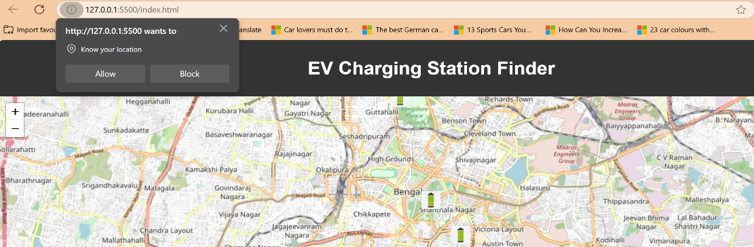
Fig 4.1.a User Interface
If user location is not valid or not recognized then it pops an error.

Fig 4.1.b Error Message
Algorithm Performance Comparison:
All the above images depict the running times and complexities of the Bellman-Ford, Floyd-Warshall, Johnson's, and Yen's K-Shortest Path algorithms, showing their efficiency. Complexity Analysis: Detailed time as well as space complexity will be given about each algorithm to help in assessing which one is best suited to work in real time, based on performance.
Route Visualization on Map:
The selected path is shown on the map, allowing the user to easily see any steps followed from the beginning to the end. Specific Navigation: Every phase of the trip is striped of the corresponding colors and contains pictograms for easier navigation.
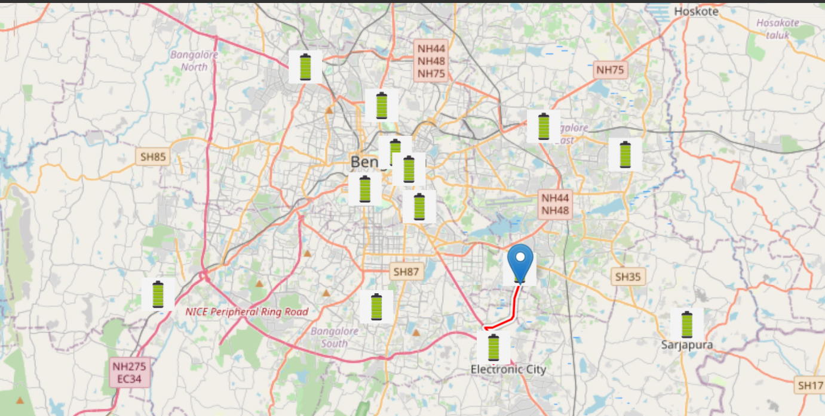
Fig 4.1.c Map
Turn-by-Turn Navigation Instructions:
Summarizes all the instructions that take you from the starting point to the endpoint, including the length of the roads involved and their respective names for precision. End of the Route: Specifies that the course has been completed and that the user has reached the last point on the map.
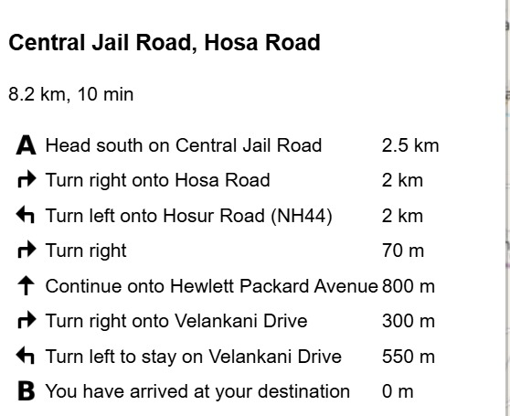
Fig 4.1.d Directions
Workflow:
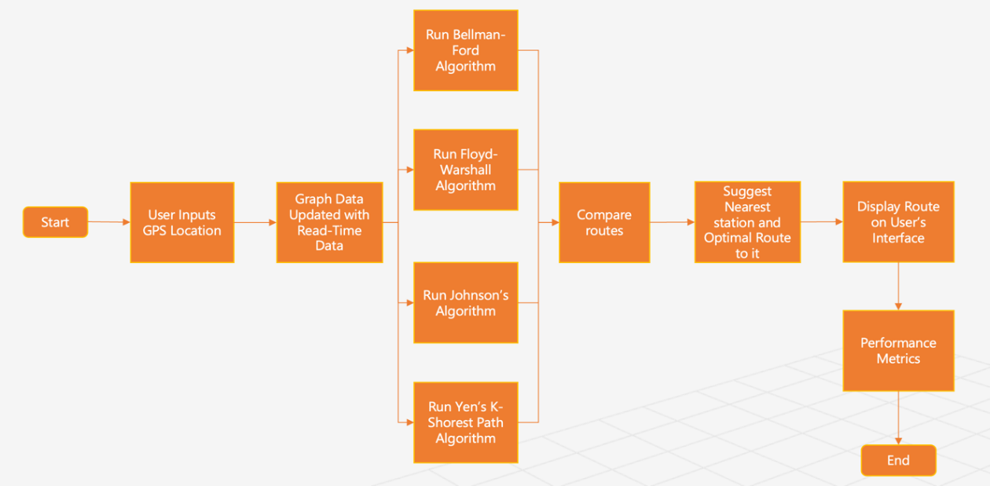

Fig 4.1.e Architecture Diagram

This workflow in Fig 4.1.a started by asking the user to input user GPS location, setting the graph data of the system to be updated with real-time information such as current traffic conditions and charging station availability. Four algorithms then applied in order, namely the algorithms of Bellman-Ford, Floyd-Warshall, Johnson's, and Yen's K-Shortest Paths. Such routes are then analyzed for the best route to the nearest charging station. In the final step, the optimal route is rendered on the user interface with performance metrics so that users obtain a better experience of navigation by providing an in-depth context of the actual situation so as to enhance the routing precision and efficiency.

4.2 LOW LEVEL DESIGN
Low-Level Design provides practical implementation and working logic because each module is described in detail.

I. Algorithm Design and Optimization:
This particular unit is focused on creating and improving the logic for path finding algorithms that will be used in the project. It commences with the geometric formulation for both the Bellman-Ford and Floyd-Warshall and also Johnson and Yen’s K-Shortest Paths algorithms. It also involves tuning of parameters and modifying the algorithm for more efficient application in real time in which these dynamic parameters such as traffic and availability of stations come into play. The principle concern is on the reduction in the amount of computational work done whilst route efficiency and precisions are taken to the maximum.
- Algorithm Implementation and Integration:
The focus of this module is on the application of the algorithms in practice to the software framework. For each algorithm, implementation specific pseudo-code is created, after which the actual algorithm is coded in JavaScript and interfaced with the backend. The implementation describes how real-time data is fed to the algorithms as well as how the output is processed to give the best possible routing decisions. This module ensures that the algorithms are devotedly implemented as designed and within performance parameters.
- System Logic and Data Handling:
Logic integration consists of associating the back-end processes with the front-end interfacing and making sure that there is data transfer within and outside the user interface with the server. Such as live traffic information and the locations of the electric vehicle charging stations for example. The module also includes aspects such as management of concurrency, recovery from failures, correctness of input, and improving speed of response to these changes to make sure that there is optimal application performance with regards to changing conditions. This module also specifies which testing strategies will be used to check the logic and functionality of the algorithms that were realized.
- Graphical User Interface (GUI):
The GUI module centers on the design and development of the user interface which is an important aspect of user interaction with the application. This module contains the design principles for construction of simple and mobile based interface using HTML, CSS and JavaScript. It explains how Leaflet is incorporated for the purpose of map display and how the GUI interacts with the server for route data provision and display. The GUI design ensures that users are always able to provide the locations to be routed from and to, view routes on the map, click on any mapped section and get information on traffic and charging stations available, as well as traffic patterns.

CHAPTER 5 – IMPLEMENTATION

5.1 EV Charging Station Routing Algorithm:
Essentials of EV Charging Station Routing Algorithm are focused on making routing solutions effective and simple for the user. The first step will be the augmentation of real time geographic information on the road network and location of EV charging stations using OpenStreetMap. This too will be a dynamic system which will undergo constant updates to include changes such as traffic conditions and the status of the charging stations.
The heart of the execution process consists of choosing and tailoring the multitasking path finding algorithms, which include Bellman-Ford, Floyd-Warshall, Johnson’s, and Yen’s K-Shortest Paths. Each algorithm is appropriate in its own way as it addresses a particular feature of the routing congestions. For instance, Bellman-Ford has been put to use in instances where shortest path computation out of a single source is required, Floyd-Warshall, is deployed because of its ability to provide a solution of shortest paths between all possible pairs, hence its use during the preprocessing of dense urban areas. Johnson algorithm optimizes for the sparse network while Yen’s K-Shortest Path algorithm is useful because it helps create more than one route enhancing user choice.
In order to make sure that real-time data is dealt with efficiently, algorithms are supplemented with a layer of logic that allows dynamic processing of updates buzzing around traffic and charging stations. As this requires a backend which is usually built in a server-side language like Node.js, it allows diverse APIs and WebSocket connection to supply the application with data in JSON format. The application makes use of geospatial routing using weighted graphs where the weights are not just based on the distance but also on the current state of the roadway and the charging stations.
Subsequently, the itineraries computed by the algorithms are forwarded to the frontend through rest apis and displayed on a dynamic map using the leaflet projection. This projection also enables the users to view the routes that they have taken or intend to take, in relation to a normal or satellite picture, which helps them to navigate and change their course on the map whenever they want. The light and flexible nature of the Leaflet ensures that the application is available both on mobile gadgets and desktop computers with, therefore, providing the users with a captivating experience.
The last stage consists of testing and optimizing the application in detail, guaranteeing performance under different circumstances and scalability with user growth. Simulation results such as computation time, routing accuracy, and user experience statistics are measured on an ongoing basis in order to improve the performance of the algorithm. This stepwise development encourages revision of the existing solution to incorporate better alts and the learned data, making it possible to engineer a sound EV charging station routing system.
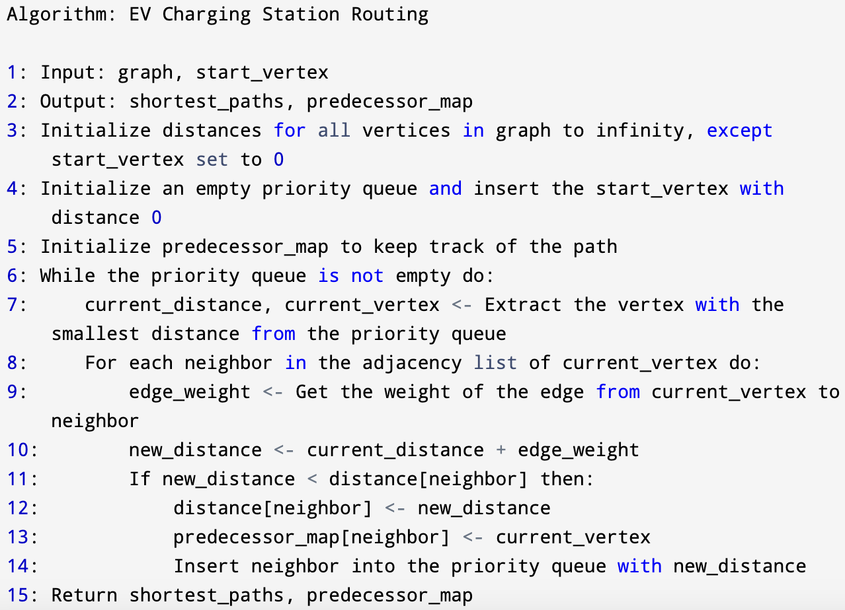
Fig 5.1 EV Charging Station Algorithm

5.2 Shortest Path Algorithms
The Bellman-Ford algorithm computes the shortest paths from a given single source vertex to all the remaining vertices of the weighted directed graph. This algorithm may be applied to graphs with negative edge weights also. Such algorithm is especially beneficial in situations where the costs of each path varies temporally and up or down changes have to be effectively managed. The algorithm has the property that if there is a shortest path to a vertex then the path can be found by applying the relaxation of all the edges of the graph several times. In addition, it can also determine the presence of negative cycles in the graph that is such a cycle whose repetition reduces the distance between the source and the destination vertices.
On the other hand, the Floyd-Warshall algorithm calculates the solution by finding the shortest paths between every possible pair of vertices in the given graph. The method is particularly suitable for dense graphs in which each vertex can act as an intermediate point and where the shortest path is updated in successive iterations. This method is suitable for graphs that may contain negative weights provided that there are no negative cycles, thus making it appropriate for problems like network analysis or real-time navigation where every possible connection must be considered.
Johnson's is an efficient algorithm for sparse graphs, which takes the benefits of both the Bellman-ford algorithm and Dijkstra's algorithm. First, Bellman-Ford is used in order to get rid of negative weights, so that Dijkstra's algorithm can be applied to all the vertices without fear of any negative cycles arising. This is particularly useful when the mesh has some edges with positive weights and some with negative ones as it reduces the problem to that of a non-negative weighted graph.
Finally, Yen’s K-Shortest Paths algorithm is unique from the rest in that it is able to look for various shortest paths from one point to other over multiple points. Its more appreciated in different situations like network routing or transportation planning where redundancy is very important where there are different routes in case the major route is blocked or something goes wrong. The algorithm starts with discovering the optimum path and afterwards looks for the other optimal paths excluding the optimum one discovered earlier ensuring that every such path is shorter than the last longer path found.
In combination these algorithms form a rich toolbox for shortest path problem solving in various types of graphs and networks, each of them being designed for very specific features of the data under analysis.

5.3 Integration of Shortest path Algorithms and Map with Real Time Traffic and Station Availability
The incorporation of shortest path algorithms, real-time traffic data, and charging stations exists a routing component that is dynamic in nature and embedded within navigation system. This is vital because it affords accurate, timely, and efficient direction-finding assistance to electric vehicle (EV) drivers in urban settings, where often the traffic on the road and the availability of chargers changes rapidly.
The cycle starts with the real-time information gathering from different parties. One of the sources for road condition information includes road sensors, GPS tracking on tens of thousands of vehicles on the road, and ground-based mobile applications that collect speed and position data over road nets. Data on charging stations, including their status, the number of chargers, and the types of chargers fast or standard, is usually obtained from charging network operators via their application programs interfaces (APIs). This information is kept live and enters into a central system respective of the routing control.
The central system makes use of shortest path algorithms, including but not limited to Dijkstra’s and Bellman-Ford algorithm, with modifications made in order to incorporate the time varying aspects of the input data. Such algorithms determine the routes not only on fixed parameters like the distance or the minimum travel time, but also on dynamic parameters such as traffic at a given moment and possible traffic jams. The algorithms vary the values associated with the edges of the graph representing the road network. For example, after calculation some highways which have heavy traffic may have higher weights which means they will take longer to travel at, while the targeted routes will not be mapped out if there are charging stations but supply no chargers.
In addition, the integration system has to be able to perform quick recalculations. The system, as the fresh data arrives, adjusts designs in order to give the drivers the best possible routes in the shortest time possible. So that this can be undertaken successfully, such equipment must have great processing power and the algorithms must be well designed to avoid excessive consumption of system resources when calculations on different routes are made.
In the end, the results of such algorithms are provided to users through a user interface, usually a smartphone application or a car navigation system, that presents the proposed routes in a clearly understandable and easy to act upon way. The interface shows the highlighted routes and provides turn-by-turn prompts with in-vehicle GPS updates that changes as the route condition adjusts or when new information about the availability of charging stations is received. This interaction does not only assist the drivers in reaching desired destinations using best possible optimum routes, but also makes the driving more enjoyable by easing the concerns regarding the range of EVs and the presence of charging stations.
The integration of shortest path finding algorithms into navigational systems along with traffic data and the presence of charging for electric vehicles into a new level thus making it an important element in the ongoing development of urban smart transportation networks.

CHAPTER 6 – RESULTS

Navigation System for Electric Vehicles: That is why we are to compare the results of using specific pathfinding algorithms and the identification of the most effective one.

The navigation system in development that will include actual traffic conditions for routing decisions along with actual availability of EV charging stations. This system, for electric vehicles, enhances the experience in that apart from avoiding jams, it will see to it that the route that is provided us will be the best route to a given end point. The below figures show the point on the map the steps of navigation from point A to B.
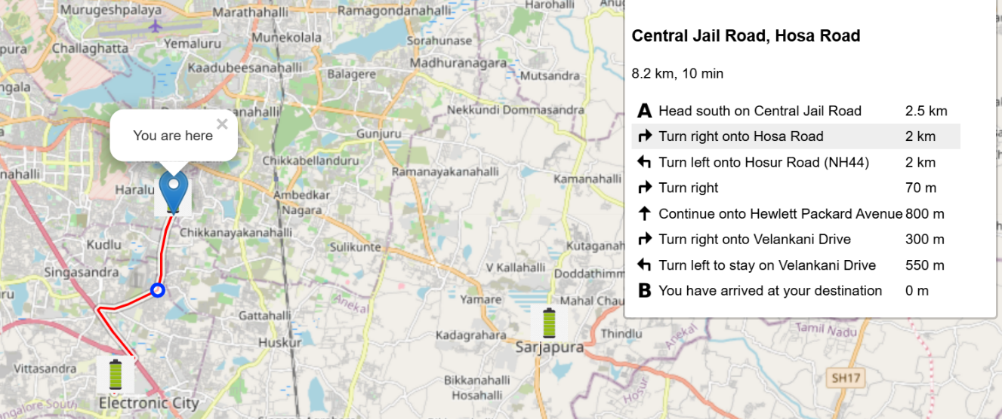
Fig 6.1.a: Next navigation point after point A
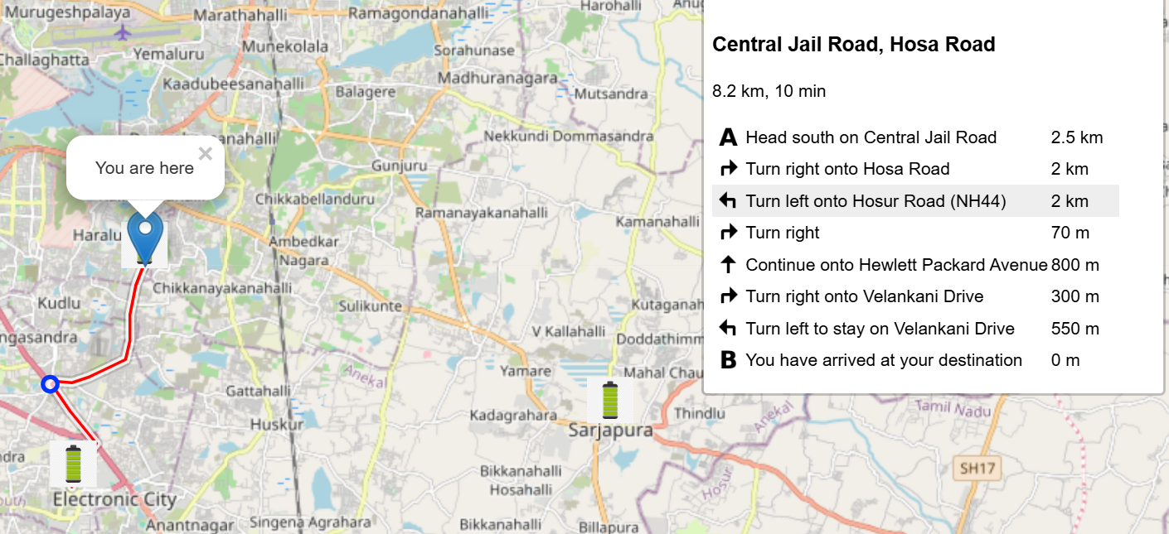
Fig 6.1.b: Next point after above point 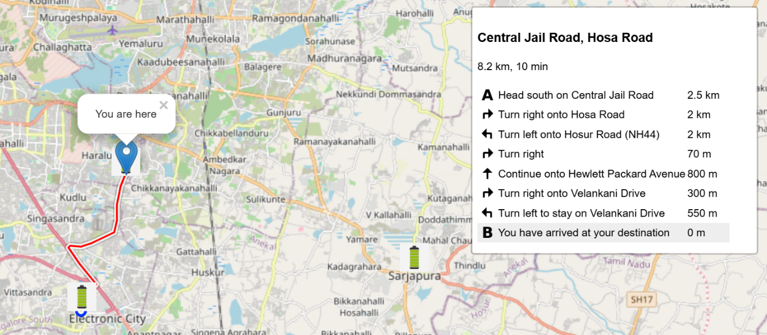
Fig 6.2.c: Final point B, destination
Real-Time Data Integration:
At the core of this system, there is a robust data assimilation model that handles On-Line data feeds from a variety of sources. Information is received from traffic sensors on the roadway, GPS data from a moving vehicle, and users via application software.

Likewise, the status of charging stations and their availability for operations vary are updated frequently. This dynamic data is updated often aiming at securing accuracy at a point of time.

Accomplished Route Search Techniques:

The techniques then employ the most current path search algorithms to handle some routing issues. It considers every possible path from origin to destination, wherein the pathways are optimized using a set of weighted factors like:

Distance, estimated travel time, Current traffic conditions, Number of charging points and their working condition.

In the event that traffic is congested or a station is not available, the system presents ONE or several other routes immediately, proactively minimizing delay and futility in travel time.
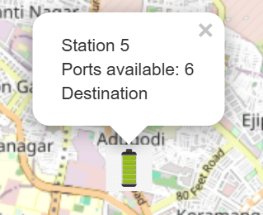
Fig 6.2: Station information

Easy-to-Use User Interface:

It has a sleek and simple design and the idealistic navigation instructions which include vocal directions and on map pointers. The functionalities include the following:

• The time to get to the destination and living speed

• Available battery life

• Charging points to be developed in the near future and their accessibility

This leads to the ability of the drivers to reason for instance by planning ahead the charging stop with reference to either the battery status or vicinity of the charging station

Choosing the Algorithm for Maximum Possible Solution:

Another part of this work is based on identifying the four key algorithms for route finding strategy, with the aim to consider which algorithm outperforms the other three. These include:

1.Bellman-Ford: Works very well for graphs with negative weight.

2.Floyd-Warshall: Excellent in finding the optimal paths for all the nodes pair that are possible in a graph.

3.Johnson's Algorithm: It is a good fit for large and sparse graphs.

4. Yen's K Shortest Path: Ideal for identifying many other potential routes.

Through these performances the system confirms that routing capabilities are sound and varied in their application; this entails that the system employs computational solutions and reliability, coupled to the ability to adapt to real time data feeds.
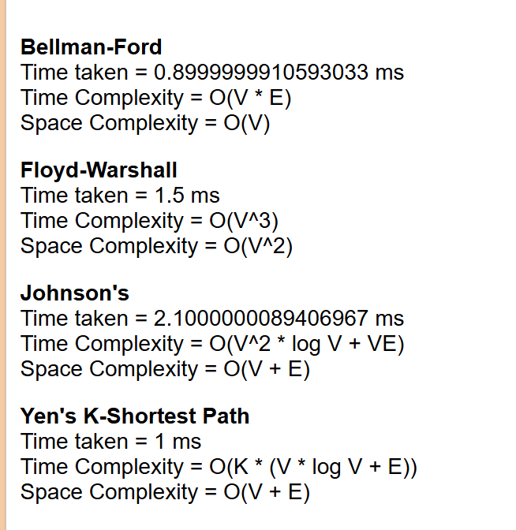
Fig 6.3: Performance comparisons of four algorithms

Future Prospects: Predictive Intelligence

On the same note, the system plans to integrate artificial intelligence for predicting the traffic pattern and availability of the charging stations. This will help not only in real-time improvement but also in the predictive, thereby leaving no room for the unnecessary increases in time and power consumption with regard to the path chosen.

Conclusion

This navigation system can serve as a rather specific example showing how computational algorithms based on big data are applied to real-time data for users’ convenience and support for sustainable transportation. It is in line with various program objectives of smart transport and sustainable cities through improving the EV travel assistance through intelligent optimization and algorithmic approaches.

CHAPTER 7 – CONCLUSION AND FUTURE ENHANCEMENT

Conclusion:
Integration of shortest path algorithms with up-to-date information on traffic conditions and real-time charging station availability will characterize this project as a notable step forward in navigation systems for electric vehicles. This system delivers improved routing that's optimized by dynamic incorporation of current traffic conditions and real-time status of the charging facilities, creating much greater levels of travel efficiency and decreasing the anxiety surrounding range limitations of EVs. This achievement not only meets the current demands of EV drivers but also is in alignment with the environmental goals as it promotes electric vehicles in better infrastructure. Additionally, the feature of updating routes based on live data demonstrates how technology can be harnessed to innovate smarter and more responsive urban transport solutions. In this regard, the developed project is a crucial step toward the innovation of smart transportation systems, demonstrating that integration of advanced computational algorithms with practical and user-centric interfaces is a viable solution to critical challenges in the sustainable mobility landscape.
Future Enhancement:
Future Directions There are various avenues through which the EV charging station routing system can be further improved: Machine learning techniques could be used to accurately predict traffic patterns and charging station availability. A potential area of development is in the use of historical data so that peak times and possible bottlenecks can be forecasted for improved predictive results. More diversity in the types of charging stations and mechanisms to incorporate feedback from users could improve user satisfaction and responsiveness of the system. There is also much potential in developing a more personalized route experience based on the preferences of the users; for example, avoiding highways, taking preference for scenic routes, or even choosing the quietest path through a route. Lastly, further scaling the system to handle large datasets and more complicated networks would lead to even better support as the use of EVs proliferates around the world. These developments would not only impact the efficiency of, and the experience for, users of the navigation system but would catalyze furthering the great adoption and sustainability of electric vehicles.

REFERENCES
[1] Proceedings of the 2016 IEEE Region 10 Conference (TENCON) : November 22-25, 2016, Marina Bay Sands, Singapore. IEEE, 2016.
[2] 2018 International Conference on Control, Electronics, Renewable Energy and Communications (ICCEREC). IEEE, 2018.
[3] J. Li, S. Tian, N. Zhang, G. Liu, Z. Wu, and W. Li, “Optimization Strategy for Electric Vehicle Routing under Traffic Impedance Guidance,” Applied Sciences (Switzerland), vol. 13, no. 20, Oct. 2023, doi: 10.3390/app132011474.
[4] M. A. Nugroho and A. Rakhmatsyah, “Simulation of Jellyfish Topology Link Failure Handling Using Floyd Warshall and Johnson Algorithm in Software Defined Network Architecture,” in 2021 9th International Conference on Information and Communication Technology, ICoICT 2021, Institute of Electrical and Electronics Engineers Inc., Aug. 2021, pp. 144–148. doi: 10.1109/ICoICT52021.2021.9527523.
[5] F. Fu and H. Dong, “Targeted optimal-path problem for electric vehicles with connected charging stations,” PLoS One, vol. 14, no. 8, Aug. 2019, doi: 10.1371/journal.pone.0220361.
[6] S. Yu, Y. Wang, R. Zhang, and J. Wang, “A Three-Step Heuristic Approach to the Electric Vehicle Path Planning Problem considering Charging,” J Adv Transp, vol. 2023, 2023, doi: 10.1155/2023/9930694.
[7] M. Akbari, M. Brenna, and M. Longo, “Optimal locating of electric vehicle charging stations by application of Genetic Algorithm,” Sustainability (Switzerland), vol. 10, no. 4, Apr. 2018, doi: 10.3390/su10041076.
[8] 2017 Annual Conference on New Trends in Information and Communications Technology Applications (NTICT). IEEE, 2017.
[9] A. Aziz, M. M. Farid, and E. Suryani, “Floyd Warshall Algorithm with FIS Sugeno for Search Evacuation Route Optimization.” [Online]. Available: www.mapcarta.com.
[10] Haviluddin. Haviluddin, Proceedings, the 2nd East Indonesia Conference on Computer and Information Technology (EIConCIT) 2018 : “Internet of Things for Industry” : 6-7 November 2018, Makassar, Indonesia. IEEE, 2018.
[11] Proceedings of the 2018 4th International Conference on Electrical Energy Systems (ICEES) : 7-9 February 2018, Department of Electrical and Electronics Engineering, SSN College of Engineering, Chennai. IEEE, 2018.
[12] P. B. Niranjane and S. Y. Amdani, “Comparison of Variants of Yen’s Algorithm for Finding K-Simple Shortest Paths,” in 2022 2nd International Conference on Intelligent Technologies, CONIT 2022, Institute of Electrical and Electronics Engineers Inc., 2022. doi: 10.1109/CONIT55038.2022.9847738.
[13] P. K. Agarwal, J. Pan, and W. Victor, “An efficient algorithm for placing electric vehicle charging stations,” in Leibniz International Proceedings in Informatics, LIPIcs, Schloss Dagstuhl- Leibniz-Zentrum fur Informatik GmbH, Dagstuhl Publishing, Dec. 2016, pp. 7.1-7.12. doi: 10.4230/LIPIcs.ISAAC.2016.7.
[14] S. Shao, F. Harirchi, D. Dave, and A. Gupta, “Preemptive scheduling of EV charging for providing demand response services,” Sustainable Energy, Grids and Networks, vol. 33, Mar. 2023, doi: 10.1016/j.segan.2022.100986.

